NPE 2018 – West Hall A, Stand W1810
Simple Solutions for advanced customer needs
At the NPE 2018 (7th to 11th Mai, 2018 in Orlando, Florida USA) motan inc. will be exhibiting a cross section of product enhancements in the following areas of materials management: drying, dosing & mixing and conveying. In particular, the new LUXOR EM A dry air dryers with integrated conveying and the SPECTROFLEX flexible wall dosing unit will be highlighted.

With the slogan “think materials management”, the company is presenting its entire portfolio of auxiliary equipment for materials management. These include solutions for dosing and mixing, drying, storage and conveying – for deployment scenarios ranging from injection molding, extrusion and blow molding to compounding applications and processes. When it comes to handling of pellets, free-flowing and non-free-flowing powders, motan inc. takes an application-driven approach. As a result, the company can find answers to all and any customer-specific challenges – and this is underlined by the number of products on display.

The volumetric dosing unit SPECTROFLEX V with flexible exchange system
Whether powder, pellets, regrind, granulate or fibers – the new SPECTROFLEX V is the volumetric dosing unit for continuous processes, designed for many different applications. Should material color, flow properties or grain size change, then motan´s unique exchange system offers a simple way to swap materials without the need of tools in under a minute.
The single- and double-screw exchange modules as well as the easy-to-clean supply hopper allow for fast and easy material changes and so reduces production downtime. A further advantage: the material loader mounted on the cover of the supply hopper does not have to be removed during the material change. Resulting in higher efficiency and shorter downtimes in your production.
LUXOR EM A - Material drying compact, mobile and flexible
For the drying of small material throughputs or for individual applications, motan has developed the new, mobile series of dry-air-dryers LUXOR E A and LUXOR EM A. Equipped with a fixed drying bin, the mobile dryers will be offered with 60, 100 or 150-liter drying bin volume. motan supplies the dryers completely pre-assembled with all customer-selected options. After a short installation, the dry-air-dryers are immediately ready for use. Only the hopper loaders must be installed after delivery. A plus is the very compact design: With a depth of only 600 millimeters, the dryers can be used flexibly even in very narrow production areas.
The next level in material selection – METROCONNECT U/C
With the new material coupling system METROCONNECT U/C, motan provides a high-quality, manual coupling station for vacuum conveying systems. Easy to use, safe and reliable in the process even for difficult materials. It forms a cost-effective solution for central material supply. The customer can choose from an uncoded version and a coded version with RFID technology.

Photo 1: SPECTROFLEX V – motan’s volumetric screw dosing unit
with flexible PU dosing hopper
(Image: motan group)

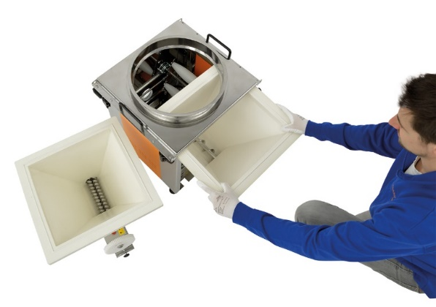
Photo 2: SPECTROFLEX V exchange modules –can be swapped easily in under a minute (Image: motan group)

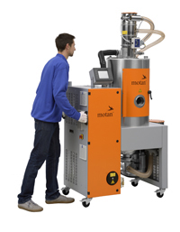
Photo 3: LUXOR EM A: compact dehumidified air dryer with integrated conveying. (Image: motan group)

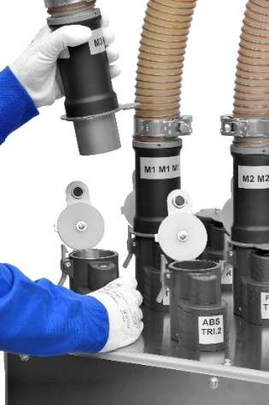
Photo 4: Coupling system METROCONNECT U/C: Simple and process-safe handling - with or without RFID coding. (Image: motan group)

The motan-group  The motan group based in Constance was founded in 1947. As leading provider for sustainable raw material handling, they operate in the areas injection moulding, blow moulding, extrusion and compounding. Innovative, modular system solutions for storage, drying and crystallisation, conveying, dosing, and mixing of raw materials for the plastics manufacturing and processing industries are part of the application orientated product range. Production takes place at different production sites in Germany, India, and China. motan distribute their products and system solutions via their regional centres. With over 500 employees currently, a yearly turnover of roughly 119 million euros is achieved. Because of their network and long-standing experience, motan can offer their customers what they really need: Individually tailored solutions with real added value. | Contact:  motan inc.  Scott Harris  VP Sales  320 N. Acorn St.  MI 49080 Plainwel  Tel. 269 685 1050  scott.harris@motan-inc.com  www.motan.com

